Fibonacci’s disappearing squares

You will need: ½ cm squared paper
Scissors
Glue
Pen, Pencil, Ruler

Task 1

Copy the square into your book.
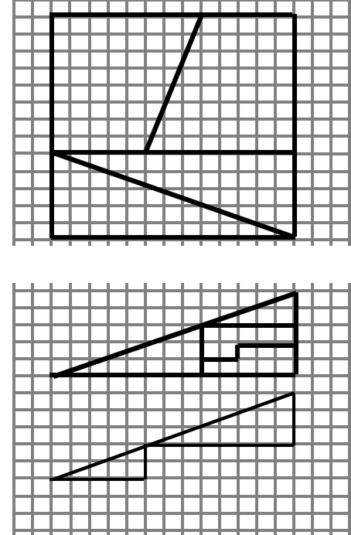What is the area of the square?

Now copy it onto squared paper using a pen to make the lines clear.
Cut the pieces out and arrange them into a rectangle.
Stick the rectangle into your book.

What is the area of the rectangle?
What do you notice about the two areas?

Task 2

Now copy the top triangle into your book.
What is its height? base?
What is its area?

Make a copy on the squared paper and cut it out.
Arrange the pieces to make a new triangle, the same size but starting as shown above.
Stick it into your book.

What has happened to the area of the triangle?
What might have caused this to happen?

Task 3

Now draw the square again, but make it three times as large and use a very sharp pencil and a ruler.
Cut it up carefully and stick it into your book using the squares in your book to line it up.

Can you see where the missing square went?

Do the same for the triangle - be careful to line the squares up when you’re sticking it into your book.
What caused the square to disappear this time?

Conclusion

What have these questions demonstrated?

What equipment should you use to draw accurately?

